|  |  |
| --- | --- |
| http://sphotos.ak.fbcdn.net/photos-ak-snc1/v2219/119/28/51288393663/n51288393663_1327303_6197.jpg | old_logo_color |

Report on Week10

By

Ahmed Usama Khalifa

Submitted to

Dr. Omar Nasr

FACULTY OF ENGINEERING, CAIRO UNIVERSITY

GIZA, EGYPT

March – 2020

**What is sequence-to-sequence learning**? **Sequence-to-sequence learning**(Seq2Seq) is about **training** models to convert **sequences** from one domain (e.g. sentences in English) to **sequences** in another domain (e.g. the same sentences translated to French).

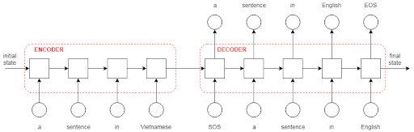

Greedy search

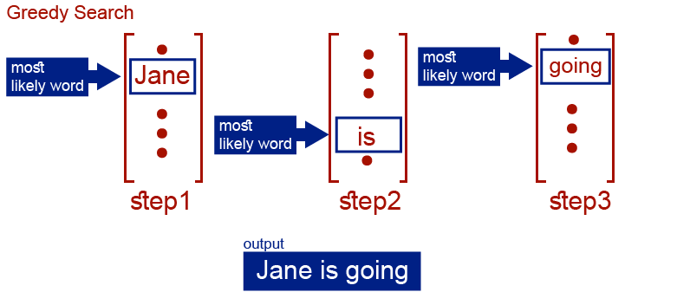

Beam search

**beam search** is a heuristic **search** algorithm that explores a graph by expanding the most promising node in a limited set. **Beam search** is an optimization of best-first **search** that reduces its memory requirements.

When we use seq2seq architecture we need a way to find the best combination of words for a translation. The most common algorithm for doing this is called beam search.

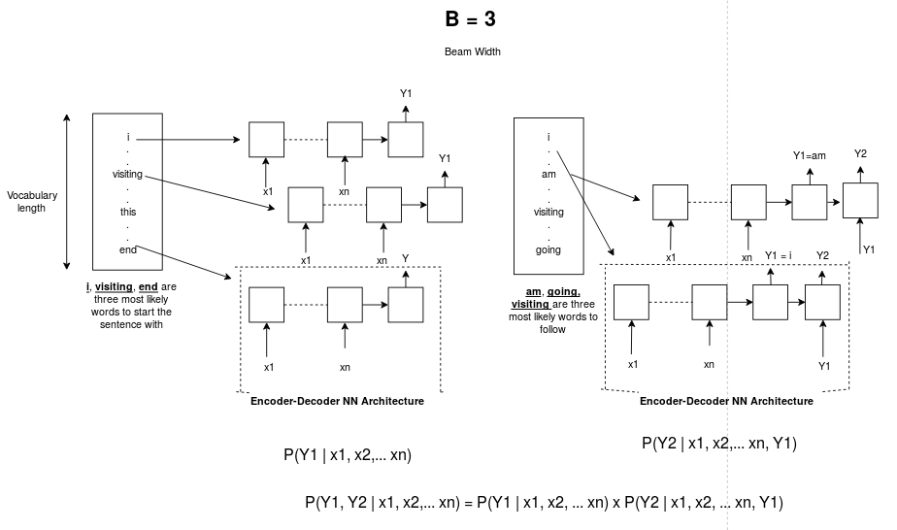

Length normalization

Length normalization is a small change to the beam search algorithm that can help get much better results.

Attention Mechanism  
